**Алгоритмы и структуры данных**

Лабораторная робота №3. Двоичные файлы

Задание 1.1

#include"pch.h"

#include"iostream"

#include"ctime"

#include"cstdlib"

#include<fstream>

using namespace std;

int main()

{

ifstream fin("Shakespeare_Winter'sTale.txt", ios::binary);

if (!fin.is_open())

{

cout << "Error, file not found!";

system("pause");

return 1;

}

ofstream fout("Shakespeare_.txt");

if (!fout.is_open())

{

cout << "Error, file not found!";

system("pause");

return 1;

}

fin.seekg(0, ios::end);

long len = fin.tellg();

cout << "Lenght file: " << len << endl;

char *buf = new char[len + 1];

fin.seekg(0, ios::beg);

fin.read(buf, len);

buf[len] = '\0';

long n = 0, i = 0;

while (buf[i])

{

if (buf[i] == '?')

{

for (int j = n; j <= i; j++)

{

if (j == i)

{

fout << buf[j] << '\n';

}

else

{

fout << buf[j];

}

}

n = i + 1;

}

if (buf[i] == '.' || buf[i] == '!' || buf[i] == '\n')

{

n = i + 1;

}

i++;

}

fout.close();

fin.close();

system("pause");

return 0;

}

Задание 1.2

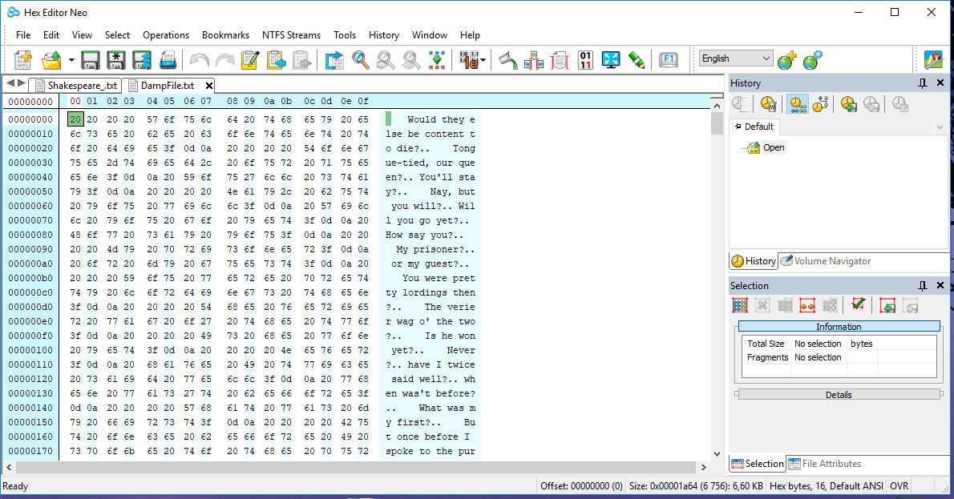

Задание 1.3a

#include"pch.h"

#include"iostream"

#include"fstream"

#include"cstdlib"

#include"cstdio"

using namespace std;

int main()

{

const int n = 10;

//int arr[n];

int *arr = new int[n];

int arr_new, i, pos;

for (i = 0; i < n; i++) {

arr[i] = rand() % 10;

cout << arr[i] << '\t';

}

ofstream fin("Z3_3.txt", ios::binary);

if (!fin.is_open()) {

cout << "error" << endl;

return 1;

}

fin.write((char*)arr, sizeof(arr)*n);

fin.close();

cout << endl;

for (i = 0; i < n; i++) {

arr[i] = 0;

cout << arr[i] << '\t';

}

cout << "\nInput number element (0 to " << n << "): ";

cin >> i;

cout << "\nInput new value element: ";

cin >> arr_new;

fstream fout("Z3_3.txt", ios::binary|ios::in|ios::out);

if (!fout.is_open()) {

cout << "error" << endl;

return 1;

}

fout.seekg(0, ios::end);

long len = fout.tellg();

cout << "File size: " << len << endl;

pos = i * sizeof(int);

cout << "Position new element: " << pos << endl;

fout.seekg(pos, ios::beg);

fout.write((char*)&arr_new, sizeof(arr_new));

fout.seekg(0);

fout.read((char*)arr, sizeof(arr)*n);

for (i = 0; i < n; i++) {

cout << arr[i] << '\t';

}

fout.close();

system("pause");

return 0;

}

Задание 1.3b

#include"pch.h"

#include"iostream"

#include"fstream"

#include"cstdlib"

#include"cstdio"

using namespace std;

int main()

{

const int n = 2,m = 5;

int arr[n][m];

//int *arr = new int[n];

int arr_new, i, pos, j;

for (i = 0; i < n; i++) {

for (int j = 0; j < m; j++) {

arr[i][j] = rand() % 10;

cout << arr[i][j] << '\t';

}

cout << endl;

}

ofstream fin("Z3_3.txt", ios::binary);

if (!fin.is_open()) {

cout << "error" << endl;

return 1;

}

fin.write((char*)arr, sizeof(arr)*n);

fin.close();

cout << endl;

for (i = 0; i < n; i++) {

for (int j = 0; j < m; j++) {

arr[i][j] = 0;

cout << arr[i][j] << '\t';

}

cout << endl;

}

cout << "\nInput number element (0 to " << n*m << "): ";

cin >> i;

cout << "\nInput new value element: ";

cin >> arr_new;

fstream fout("Z3_3.txt", ios::binary|ios::in|ios::out);

if (!fout.is_open()) {

cout << "error" << endl;

return 1;

}

fout.seekg(0, ios::end);

long len = fout.tellg();

cout << "File size: " << len << endl;

pos = i * sizeof(int);

cout << "Position new element: " << pos << endl;

fout.seekg(pos, ios::beg);

fout.write((char*)&arr_new, sizeof(arr_new));

fout.seekg(0);

fout.read((char*)&arr, sizeof(arr));

for (i = 0; i < n; i++) {

for (int j = 0; j < m; j++) {

cout << arr[i][j] << '\t';

}

cout << endl;

}

fout.close();

system("pause");

return 0;

}

Задание 1.4

#include"pch.h"

#include"iostream"

#include"fstream"

#include"cstdlib"

#include"cstdio"

using namespace std;

int main()

{

int n = 10;

int *arr = new int[n];

int arr_new, k, pos;

for (int i = 0; i < n; i++) {

arr[i] = rand() % 10;

cout << arr[i] << '\t';

}

ofstream fin("Z3_3.txt", ios::binary);

if (!fin.is_open()) {

cout << "error" << endl;

return 1;

}

fin.write((char*)arr, sizeof(arr)*n);

fin.close();

cout << endl;

for (int i = 0; i < n; i++) {

arr[i] = 0;

cout << arr[i] << '\t';

}

cout << "\nInput number element (0 to " << n << "): ";

cin >> k;

fstream fout("Z3_3.txt", ios::binary | ios::in | ios::out);

if (!fout.is_open()) {

cout << "error" << endl;

return 1;

}

fout.seekg(0, ios::end);

long len = fout.tellg();

cout << "File size: " << len << endl;

pos = k * sizeof(int);

cout << "Position new element: " << pos << endl;

fout.seekg(0);

fout.read((char*)arr, sizeof(arr)*n);

for (int i = k; i < n; i++) {

arr[i] = arr[i+1];

}

--n;

for (int i = 0; i < n; i++) {

cout << arr[i] << '\t';

}

fout.close();

system("pause");

return 0;

}

Задание 1.6

#include"pch.h"

#include"iostream"

#include"fstream"

#include"cstdlib"

#include"string"

using namespace std;

int const N = 1024;

int main()

{

ifstream *fin = new ifstream[2];

for (int i = 0; i < 2; i++) {

cout << "Input name file: ";

string s;

cin >> s;

fin[i].open(s.c_str(), ios::binary | ios::in);

if (!fin[i].is_open()) {

cout << "Error file!" << endl;

i--;

}

}

unsigned char buf1[N], buf2[N];

cout << "File compare... " << endl;

do {

fin[0].read((char*)buf1, sizeof buf1);

fin[1].read((char*)buf2, sizeof buf2);

int f1 = fin[0].gcount();

int f2 = fin[1].gcount();

if (f1 != f2) {

cout << "File different sizeof." << endl;

fin[0].close();

fin[1].close();

return 0;

}

else {

for (int j = 0; j < f1; j++) {

if (buf1[j] != buf2[j]) {

cout << "File has different content." << endl;

fin[0].close();

fin[1].close();

return 0;

}

}

}

} while (!fin[0].eof() || !fin[1].eof());

cout << "File the same!" << endl;

fin[0].close();

fin[1].close();

system("pause");

return 0;

}